306 algorithm

**State Space Search**

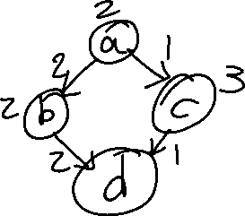

**Abcd on 2 processors**

**32 possible schedule**

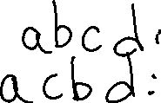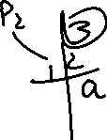

**Each state is a partial solution**

State: partial schedule

Initial state: empty schedule

Cost Function f(s): underestimate of makespan for complete schedule based on s.

Given state s, let free(s) be free tasks

For all i∈free(s) do

For all Pi∈P do

Create new state: I scheduled on Pi as early as possible

B 🡨 upperBound

DFS on state space (depth until f(s)>=B)

If complete solution sc found &f(sc)<B then

B🡨f(sc)

That was DFS branch and bound

B&B (branch and bound part)

Find the first solution and use it as a bound

Use queue structure to store tree

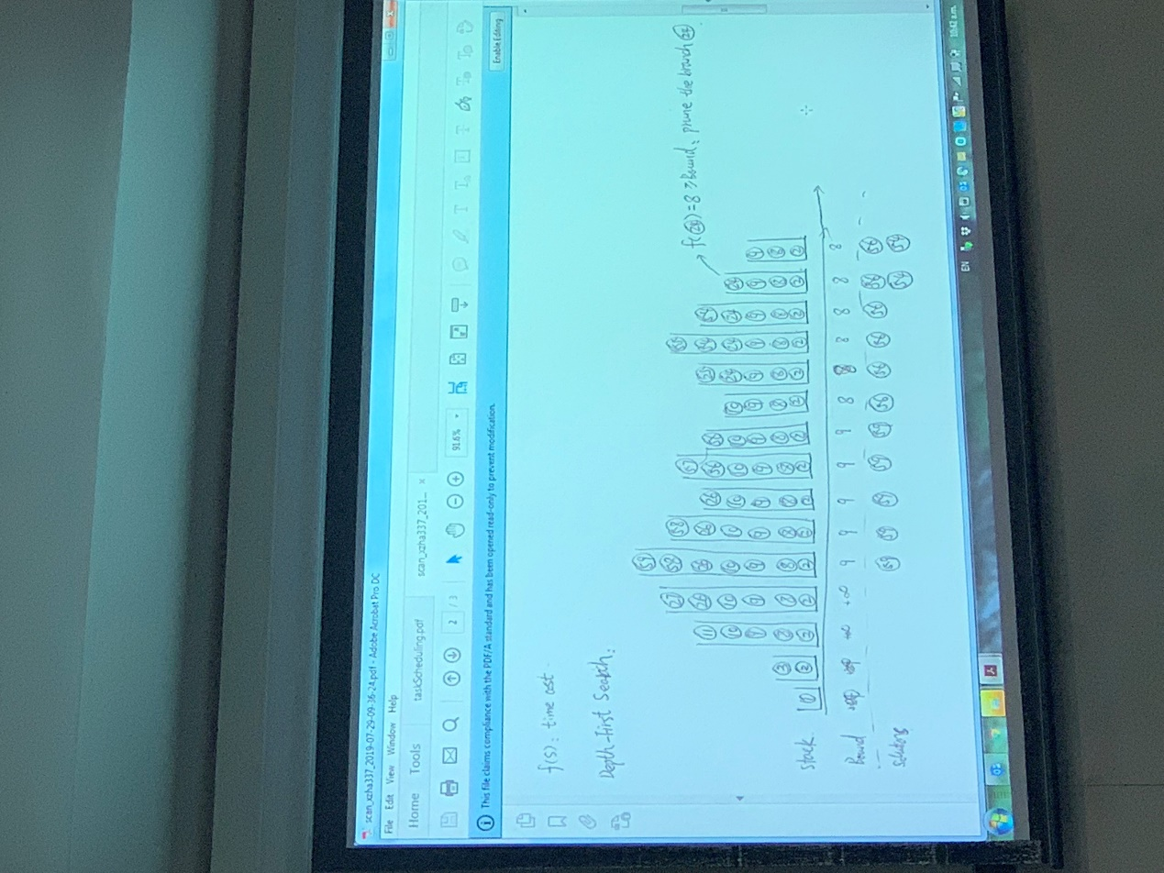

In computer science, A* (pronounced "A-star") is a computer algorithm that is widely used in pathfinding and graph traversal, which is the process of finding a path between multiple points, called "nodes". It enjoys widespread use due to its performance and accuracy. However, in practical travel-routing systems, it is generally outperformed by algorithms which can pre-process the graph to attain better performance,[1] although other work has found A* to be superior to other approaches.

branch and bound(DFS)is an algorithm design paradigm for discrete and combinatorial optimization problems, as well as mathematical optimization. A branch-and-bound algorithm consists of a systematic enumeration of candidate solutions by means of state space search: the set of candidate solutions is thought of as forming a rooted tree with the full set at the root. The algorithm explores branches of this tree, which represent subsets of the solution set. Before enumerating the candidate solutions of a branch, the branch is checked against upper and lower estimated bounds on the optimal solution, and is discarded if it cannot produce a better solution than the best one found so far by the algorithm.

The algorithm depends on efficient estimation of the lower and upper bounds of regions/branches of the search space. If no bounds are available, the algorithm degenerates to an exhaustive search.

Where we implemented both of the algorithms, the user is allowed to switch between them.